Section Two Questions
1.
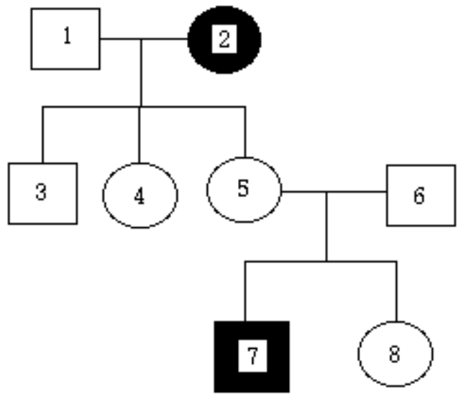
Alkaptonuria is a rare genetically-determined condition found in humans. The urine of people with this condition is deep-brown and eventually changes to black on exposure to air.
- What is the mode or pattern of inheritance for this condition? Explain your reasoning.
- What is the most likely genotype and phenotype of individual 7? Explain your reasoning and any symbols used.
- What could be the predicted ratios and possible genotypes and phenotypes of children born to parents 5 and 6?
- What is the most likely genotype and phenotype of individual 4? Explain your reasoning and any symbols used.

2. Summarise, in the table below, the process of Meiosis in humans with reference to
i. the number of chromosomes
ii the number of chromatids and
- the overall quantity of DNA that is present at each of the stages.
(Some information has already been filled in for you)

STAGE | NUMBER OF CHROMOSOMES | NUMBER OF CHROMATIDS | QUANTITY OF DNA  (UNITS)
INTERPHASE 1 |  |  | 10

Section 3

- Geneticists study the inheritance of genetic conditions. Sickle Cell Anaemia, PKU and Red Green Colour Blindness are all genetic disorders that have been identified in Australian populations.

  - Discuss and explain the
- pattern of inheritance
  - symptoms and
  - possible treatments or management of one of the following genetic disorders

Sickle cell anemia OR Phenylketonuria (PKU) OR Red Green Colour Blindness

b. The treatment of genetic disorders can involve any of three different methods
i. prevention of symptoms
ii. replacement therapy or
iii. gene therapy

Discuss how each of these treatments could be applied to your selected genetic disorder.

